Project Title : Lab Attendance Register (L61)

Name : Vamja Maitri Nileshbhai

Roll no : H34

Div : H

Enrollment No : 24004501210467

Subject : Linux Operating System / Shell Scripting Lab

Project Structure:

data/, lib/, logs/, reports/, backups/, main.sh, README.md
- Runs main.sh to display the interactive Lab Attendance Register menu (options 1–8 and 0) using a Bash while loop.

- Captures user input with read -p, routes actions using a case...esac statement, and terminates cleanly when selecting option 0.
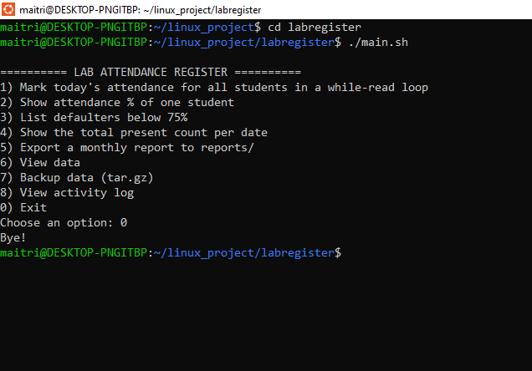
Figure 1

- Iterates through all students in students.txt line by line using a while read loop, prompting for attendance status (P or A) via /dev/tty.

- Validates user input and appends each marked record with today's date directly into data/attendance.csv.
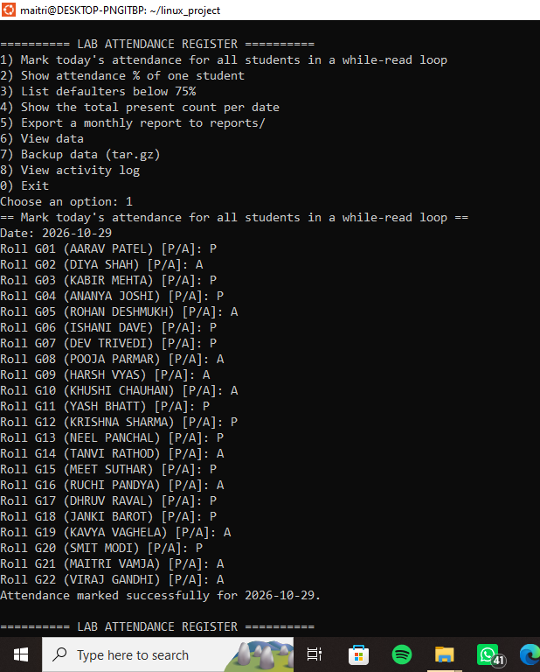
Figure 2
__________________________________________________________
- Prompts for a specific student's roll number, looks up their name from students.txt, and tallies total vs. present sessions using grep.

- Calculates attendance percentage using awk and prints the formatted summary on screen while logging the action.
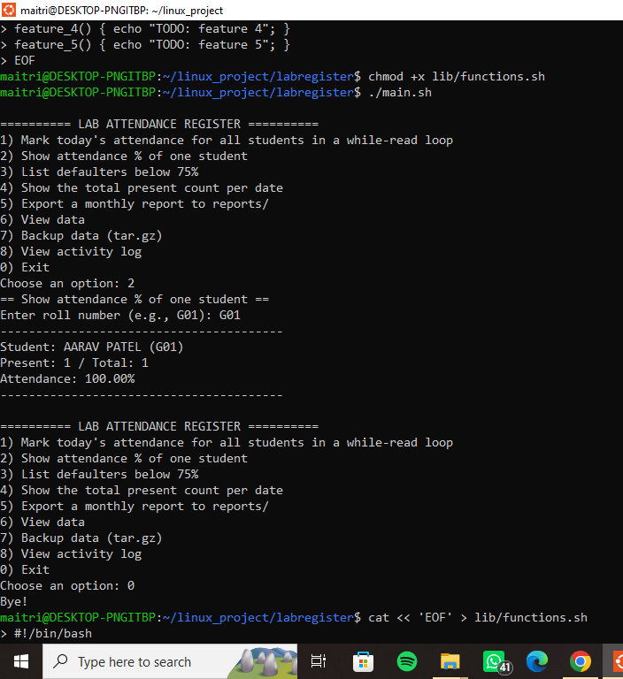
Figure 3
__________________________________________________________
- Iterates through every student record, calculates individual attendance percentages, and filters those falling below 75% using awk.

- Formats and prints defaulter details (Roll, Name, Attendance ratio, and Percentage) in an aligned table layout on screen.
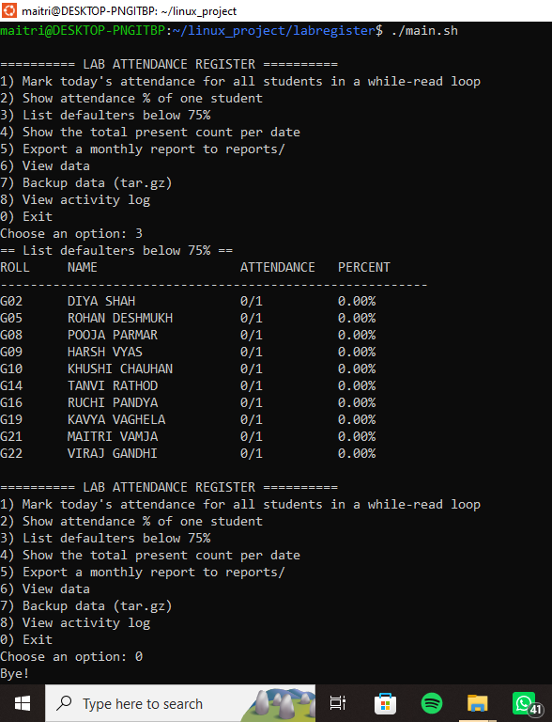
Figure 4
__________________________________________________________
- Scans data/attendance.csv to find all entries marked with status P on each recorded date.

- Uses an awk associative array to sum up daily attendees and prints the final count alongside the corresponding date.
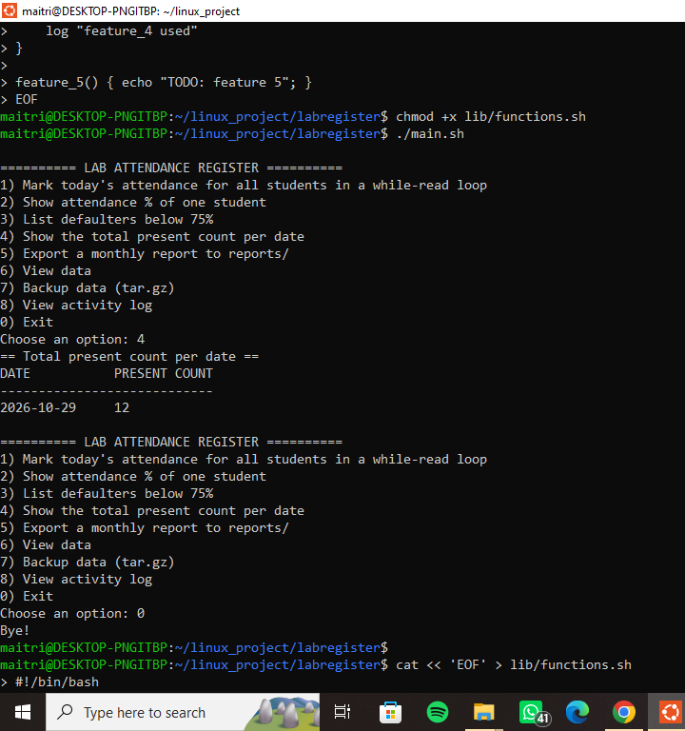
Figure 5 __________________________________________________________
- Aggregates daily attendance figures and identifies students with attendance below 75% into a single dated document inside reports/.

- Generates the file report_2026-10-29.txt and prints its complete summary on the console for immediate review.
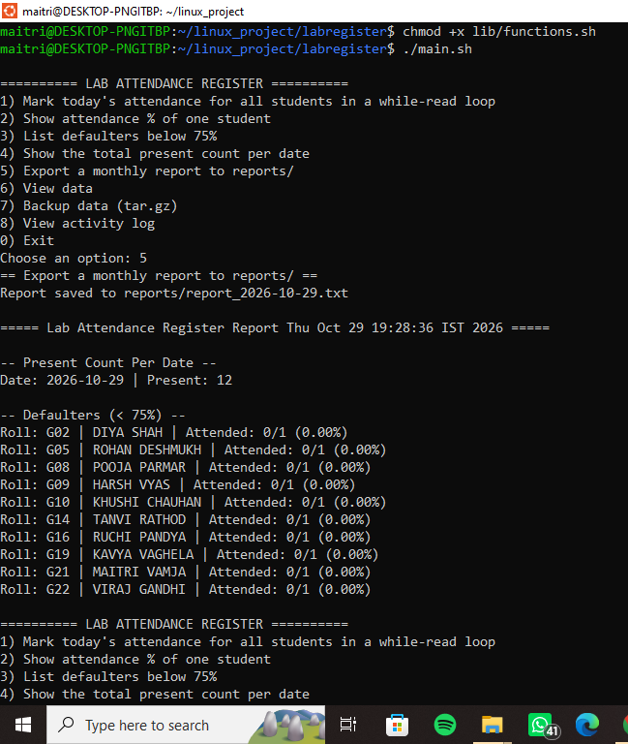
Figure 6
- Invokes the activity log viewer to display timestamped records directly from logs/activity.log.

- Confirms continuous audit tracking by listing each executed feature alongside its date, time, and specific parameters.
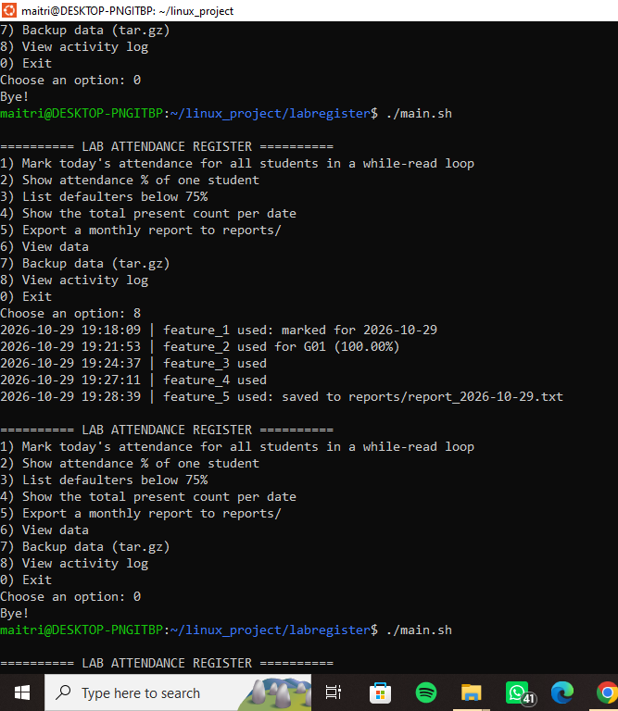
Figure 7
__________________________________________________________
- Tests command-line flags (--help, --backup, --cron) to generate data archives and schedules a daily 5 PM automated backup via crontab.

- Bundles the entire project into the submission tarball H34_L61_labregister.tar.gz, verifies its contents with tar -tzf, and exports it to the Windows Desktop.
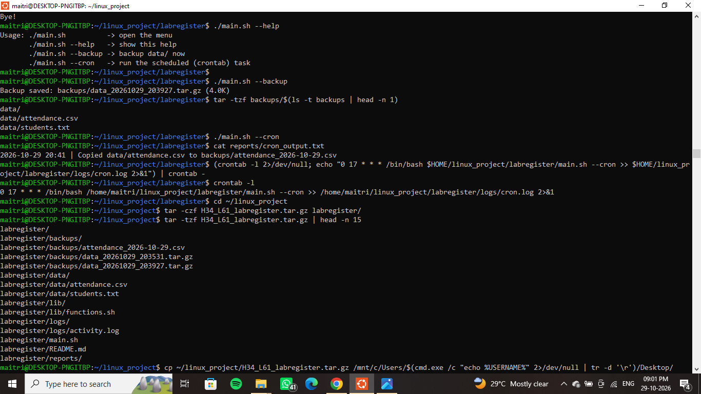
Figure 8

